Karel_EC4_NumberSystem

Introduction: If you have enjoyed Incredibly Cruel Torture (ICT, a.k.a. CLA) you are already knowledgeable of different Number Base system. If you are not knowledgeable of different Number Bases you may need to further investigate the topic. Basically, in the decimal number system (base 10), the place values are powers of 10, and the digit in each place value represents the quantity (how many) of that place value.
Non-decimal examples follow (with base indicated by subscripted number, _{n}):
- 120₃ = 1 * 3² + 2 * 3¹ + 0 * 3⁰ = 15
- 74205₉ = 7 * 9⁴ + 4 * 9³ + 2 * 9² + 0 * 9¹ + 5 * 9⁰ = 49010

The task, part 1: Convert a 5 digit binary number (Base 2) to decimal!

Copy the folder BinaryRobot_Student to you work area. Open in BlueJ and compile/execute MainDriver1. (MainDriver2 is for the part 2 of this lab.) A world should appear which contains two BinaryRobots, and single beepers as shown in the diagram below. (All BinaryRobots are constructed with an infinite number of beepers.) Each Street represents a binary number where a beeper indicates a one in that place value and no beepers indicate a zero in that place value. The Beeper closes to the BinaryRobot is the most significant digit. In this case, Avenue 2 is the 2⁴ place value; Avenue 3 is the 2³ place value; Avenue 4 is the 2² place value; etc. No beepers will be on Avenue 7. You are to implement the task method so that each BinaryRobot traverses the Street and deposits the number of beepers in front of the wall (Avenue 7) equaling the decimal equivalent of the binary number. Note that your task method should be able to handle any five digit binary number including the number 0. In the world below, five beepers should be placed at Avenue 7 and Street 1, with 26 Beepers placed at Avenue 7 and Street 2.
You’ve correctly implement the task method when successfully passing all in testing units in the BinaryRobotUnitTest. Notice that no restrictions have been put on treatment of existing beepers. This allows your implementation to either test for a beeper or to pickup existing beepers.
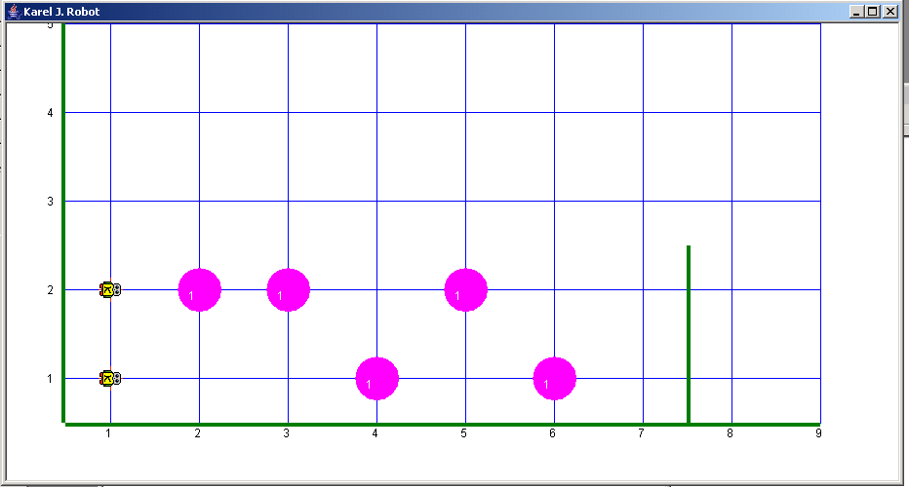
The task, part 2: Convert non-decimal numbers to decimal!

Compile/execute MainDriver2. A world should appear which contains seven GeneralRobots, and beepers as shown in the following diagram. Each Street represents a non-decimal number where the number of beepers indicates the digit in that place value (no beepers indicate a zero). In this world, as in MainDriver1, the wall indicates the end of the number (with one corner open for the placement of the beepers); however, in this case not all numbers are five digits long. When the Robots are constructed, they are given an infinite number of beepers and are given the base of the number. The base of the Robot can be determine by the method getBase(). The Beeper closes to the GeneralRobot is the most significant digit.
Three examples in the following world:
- The GeneralRobot at the origin (1, 1) was constructed with a base of 2, therefore; Avenue 2 is the 2² place value; Avenue 3 is the 2¹ place value and Avenue 4 is the 2⁰ place value. Five beepers should be placed at Avenue 5.
- The GeneralRobot at the Street 2 and Avenue 1 was constructed with a base of 5, therefore; Avenue 2 is the 5³ place value; Avenue 3 is the 5² place value; Avenue 4 is the 5¹ place value and Avenue 5 is the 5⁰ place value. 30 beepers should be placed at Avenue 6.
- The GeneralRobot at the Street 6 and Avenue 1 was constructed with a base of 16, therefore; Avenue 2 is the 16² place value; Avenue 3 is the 16¹ place value and Avenue 4 is the 16⁰ place value. 2*16² + 15*16 beepers should be placed at Avenue 5.
You are to implement the task method so that each GeneralRobot traverses the Street and deposits the number of beepers in front of the wall equaling the decimal equivalent of the given number. Note that your task method should be able to handle any number of digits, any base > 0 and any decimal equivalent including 0. The correct number of beepers for each Street is specified in MainDriver2 as a comment for each GeneralRobot.

When you think you correctly implement the task method, test all in GeneralRobotUnitTest.

One final comment. When executing/testing your program, if you minimize BlueJ, a control panel appears allowing you to increase the speed at which the program executes.
